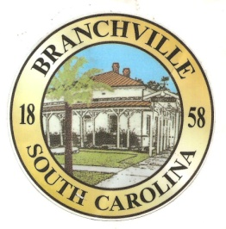
Frank Quattlebaum
Judge
Randy Clark
Chief of Police
Madison Jackson
Town Clerk / Treasurer

Emily Maynard
Clerk of Court
H. Franklin Dickson
Mayor

Council
Gregory Oliver
Charles Dukes
Brett Banks
Pauley Jumper
Tommy Connelly
Rhonda Peeples

Town of Branchville
Oldest Railroad Junction in the World
Town of Branchville
Mayor H. Franklin Dickson, Presiding
Regular Council Meeting
Monday December 12th, 2022
7:00 PM
Agenda

- Call to Order Mayor Dickson
- Pledge of Allegiance
- Prayer
- Roll Call Clerk Jackson
- Welcome of Guest Mayor Dickson
- Approval of Minutes– November 14th, 2022 Mayor Dickson
- Approval of Financial Reports – General Fund November 2022 Mayor Dickson
- Council Report:
- City Hall/License/Insurance Councilman Jumper
- Water, Sewer and Streets Councilman Connelly
Approval of Financial Reports- Water & Sewer November 2022
- Park & Recreation Councilman Banks
- Projects/Events Councilwoman Peeples
- Buildings and Grounds
Speed Limit Signs Reeves Branch Mayor Pro Tem Oliver
- Police Department Councilman Dukes
Approval of Financial Reports-Municipal Court November 2022
- Old Business:
- New Business:
- Public Comments - Agenda Items – 3 minutes per person
- Public Comments – Other items – 3 minutes per person
- Items for Information
- Executive Session:
- Adjournment

7644 Freedom Rd, Post Office Box 85
Branchville, South Carolina 29432
Telephone (803) 274-8820 Fax (803) 274-8760 Police (803) 274-8000
www.Branchville.SC.gov

