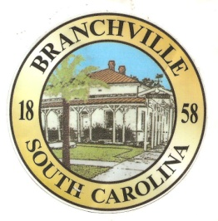

Frank Quattlebaum

**Judge**

Randy Clark

**Chief of Police**

Madison Jackson

**Town Clerk / Treasurer**

Emily Maynard

**Clerk of Court**

H. Franklin Dickson

**Mayor**

**Council**

Gregory Oliver

Charles Dukes

Brett Banks

Pauley Jumper

Tommy Connelly

Rhonda Peeples

Town of Branchville

*Oldest Railroad Junction in the World*

Town of Branchville

Mayor H. Franklin Dickson, Presiding

Regular Council Meeting

Monday November 14th, 2022

7:00 PM

Agenda

1. Call to Order Mayor Dickson
2. Pledge of Allegiance
3. Prayer
4. Roll Call Clerk Jackson
5. Welcome of Guest Mayor Dickson
6. Approval of Minutes– October 10th, 2022
7. Approval of Budget Minutes- October 25th, 2022 Mayor Dickson
8. Approval of Financial Reports – General Fund October 2022 Mayor Dickson
9. Council Report:
10. City Hall/License/Insurance Councilman Jumper
11. Water, Sewer and Streets Councilman Connelly

Approval of Financial Reports- Water & Sewer October 2022

1. Park & Recreation Councilman Banks
2. Projects/Events Councilwoman Peeples
3. Buildings and Grounds Mayor Pro Tem Oliver
4. Police Department Councilman Dukes

Approval of Financial Reports-Municipal Court October 2022

1. Old Business:
2. New Business:

Approval of 2023 Council Meeting Schedule

Amendment to Council Salary 1st read

Contractual Matters FEMA 1st read

1. Public Comments - Agenda Items – 3 minutes per person
2. Public Comments – Other items – 3 minutes per person
3. Items for Information
4. Executive Session:

Personnel Matters

Victims Assistance

1. Adjournment

7644 Freedom Rd, Post Office Box 85

Branchville, South Carolina 29432

Telephone (803) 274-8820 Fax (803) 274-8760 Police (803) 274-8000

[www.Branchville.SC.gov](http://www.Branchville.SC.gov)