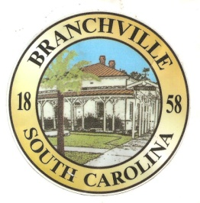

Frank Quattlebaum

**Judge**

Randy Clark

**Chief of Police**

Madison Jackson

**Town Clerk / Treasurer**

Emily Maynard

**Clerk of Court**

H. Franklin Dickson

**Mayor**

**Council**

Gregory Oliver

Brett Banks

Pauley Jumper

Tommy Connelly

Rhonda Peeples

Town of Branchville

*Oldest Railroad Junction in the World*

Town of Branchville

Mayor H. Franklin Dickson, Presiding

Regular Council Meeting

Monday February 13th, 2023

7:00 PM

Agenda

1. Call to Order Mayor Dickson
2. Pledge of Allegiance
3. Prayer
4. Roll Call Clerk Jackson
5. Welcome of Guest Mayor Dickson
6. Approval of Minutes–January 9th, 2023 Mayor Dickson
7. Approval of Financial Reports – General Fund January 2023 Mayor Dickson
8. Council Report:
9. City Hall/License/Insurance Councilman Jumper
10. Water, Sewer and Streets Councilman Connelly

Approval of Financial Reports- Water & Sewer January 2023

1. Park & Recreation Councilman Banks
2. Projects/Events Councilwoman Peeples
3. Buildings and Grounds Mayor Pro Tem Oliver
4. Police Department

Approval of Financial Reports-Municipal Court January 2023

1. Old Business:
2. New Business:
3. Public Comments - Agenda Items – 3 minutes per person
4. Public Comments – Other items – 3 minutes per person
5. Items for Information
6. Executive Session:

Orangeburg County Clean-up Day

Uni-First Contract

Personnel Matters

1. Adjournment

7644 Freedom Rd, Post Office Box 85

Branchville, South Carolina 29432

Telephone (803) 274-8820 Fax (803) 274-8760 Police (803) 274-8000

[www.Branchville.SC.gov](http://www.Branchville.SC.gov)