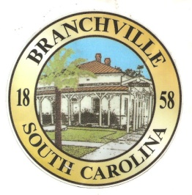

Frank Quattlebaum

**Judge**

Randy Clark

**Chief of Police**

Madison Jackson

**Town Clerk / Treasurer**

Emily Maynard

**Clerk of Court**

H. Franklin Dickson

**Mayor**

**Council**

Gregory Oliver

Brett Banks

Pauley Jumper

Tommy Connelly

Rhonda Peeples

Town of Branchville

*Oldest Railroad Junction in the World*

Town of Branchville

Mayor H. Franklin Dickson, Presiding

Regular Council Meeting

Monday January 9th, 2023

7:00 PM

Agenda

1. Call to Order Mayor Dickson
2. Pledge of Allegiance
3. Prayer
4. Roll Call Clerk Jackson
5. Welcome of Guest Mayor Dickson
6. Approval of Minutes– December 12th , 2022
7. Approval of Budget Minutes – December 12th,2022 Mayor Dickson
8. Approval of Financial Reports – General Fund December 2022 Mayor Dickson
9. Council Report:
10. City Hall/License/Insurance Councilman Jumper
11. Water, Sewer and Streets Councilman Connelly

Approval of Financial Reports- Water & Sewer December 2022

1. Park & Recreation Councilman Banks
2. Projects/Events

February 11th Arts & Craft Fair/ Yard sale Councilwoman Peeples

1. Buildings and Grounds Mayor Pro Tem Oliver
2. Police Department

Approval of Financial Reports-Municipal Court December 2022

1. Old Business:
2. New Business:

Opening of Walking Track

1. Public Comments - Agenda Items – 3 minutes per person
2. Public Comments – Other items – 3 minutes per person
3. Items for Information
4. Executive Session:
5. Adjournment

7644 Freedom Rd, Post Office Box 85

Branchville, South Carolina 29432

Telephone (803) 274-8820 Fax (803) 274-8760 Police (803) 274-8000

[www.Branchville.SC.gov](http://www.Branchville.SC.gov)