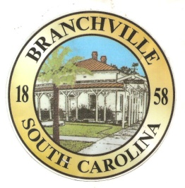

Frank Quattlebaum

**Judge**

Randy Clark

**Chief of Police**

Theresa Polin

**Town Clerk / Treasurer**

Emily Maynard

**Clerk of Court**

H. Franklin Dickson

**Mayor**

**Council**

Gregory Oliver

Pauley Jumper

Tommy Connelly

Rhonda Peeples

Clayton Baker

Frank Ott

Town of Branchville

*Oldest Railroad Junction in the World*

Town of Branchville

Mayor H. Franklin Dickson, Presiding

Regular Council Meeting

Monday May 13th 2024

6:00 PM

Agenda

1. Call to Order Mayor Dickson
2. Pledge of Allegiance
3. Prayer
4. Roll Call Clerk Maynard
5. Welcome of Guest
6. Approval of Minutes– April 8th 2024 Mayor Dickson
7. Approval of Financial Reports – General Fund April 2024 Mayor Dickson
8. Council Report:
9. City Hall/License/Insurance Councilman Baker
10. Water, Sewer and Streets Mayor Pro Tem Connelly

Approval of Financial Reports- Water & Sewer April 2024

1. Parks & Recreation Councilman Ott
2. Projects/Events Councilwoman Peeples
3. Buildings and Grounds Councilman Oliver
4. Police Department Councilman Jumper

Approval of Financial Reports-Municipal Court April 2024

1. Old Business:
2. New Business:
3. Public Comments - Agenda Items – 3 minutes per person
4. Public Comments – Other items – 3 minutes per person
5. Items for Information
6. Executive Session
   1. Contractual Matters
7. Adjournment

7644 Freedom Rd, Post Office Box 85

Branchville, South Carolina 29432

Telephone (803) 274-8820 Fax (803) 274-8760 Police (803) 274-8000

[www.Branchville.SC.gov](http://www.Branchville.SC.gov)