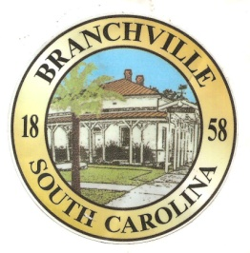

Frank Quattlebaum

**Judge**

Randy Clark

**Chief of Police**

Madison Jackson

**Town Clerk / Treasurer**

Emily Maynard

**Clerk of Court**

H. Franklin Dickson

**Mayor**

**Council**

Gregory Oliver

Brett Banks

Pauley Jumper

Tommy Connelly

Rhonda Peeples

Clayton Baker

Town of Branchville

*Oldest Railroad Junction in the World*

Town of Branchville

Mayor H. Franklin Dickson, Presiding

Regular Council Meeting

Monday, August 14th, 2023

7:00 PM

Agenda

1. Call to Order Mayor Dickson
2. Pledge of Allegiance
3. Prayer
4. Roll Call Clerk Jackson
5. Welcome of Guest Mayor Dickson
6. Approval of Minutes– July 11th 2023 Mayor Dickson
7. Approval of Financial Reports – General Fund July 2023 Mayor Dickson
8. Council Report:
9. City Hall/License/Insurance Councilman Baker
10. Water, Sewer and Streets Councilman Connelly

Approval of Financial Reports- Water & Sewer July 2023

1. Park & Recreation Councilman Banks
2. Projects/Events Councilwoman Peeples
3. Buildings and Grounds Mayor Pro Tem Oliver
   1. Playground Equipment
   2. Community Center Updates
4. Police Department Councilman Jumper

Approval of Financial Reports-Municipal Court July 2023

1. Old Business:
   1. Final Reading Business License Amendment
2. New Business:
3. Public Comments - Agenda Items – 3 minutes per person
4. Public Comments – Other items – 3 minutes per person
5. Items for Information
6. Executive Session:
   1. Budgetary Matters
7. Adjournment

7644 Freedom Rd, Post Office Box 85

Branchville, South Carolina 29432

Telephone (803) 274-8820 Fax (803) 274-8760 Police (803) 274-8000

[www.Branchville.SC.gov](http://www.Branchville.SC.gov)