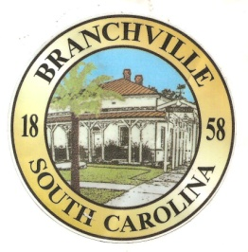

Frank Quattlebaum

**Judge**

Randy Clark

**Chief of Police**

Madison Jackson

**Town Clerk / Treasurer**

Emily Maynard

**Clerk of Court**

H. Franklin Dickson

**Mayor**

**Council**

Gregory Oliver

Brett Banks

Pauley Jumper

Tommy Connelly

Rhonda Peeples

Clayton Baker

Town of Branchville

*Oldest Railroad Junction in the World*

Town of Branchville

Mayor H. Franklin Dickson, Presiding

Budget Work Session

Thursday December 28th, 2023

6:00 PM

Agenda

1. Call to Order Mayor Dickson
2. Pledge of Allegiance
3. Prayer
4. Roll Call Clerk Maynard
5. Welcome of Guest Mayor Dickson
6. Budget Work Session Mayor Dickson
7. Adjournment

7644 Freedom Rd, Post Office Box 85

Branchville, South Carolina 29432

Telephone (803) 274-8820 Fax (803) 274-8760 Police (803) 274-8000

[www.Branchville.SC.gov](http://www.Branchville.SC.gov)