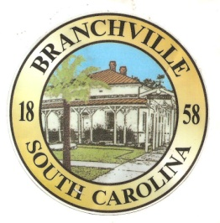

Frank Quattlebaum

**Judge**

Randy Clark

**Chief of Police**

Madison Jackson

**Town Clerk / Treasurer**

Emily Maynard

**Clerk of Court**

`H. Franklin Dickson

**Mayor**

**Council**

Gregory Oliver

Pauley Jumper

Tommy Connelly

Rhonda Peeples

Clayton Baker

`1

Town of Branchville

*Oldest Railroad Junction in the World*

Town of Branchville

Mayor H. Franklin Dickson, Presiding

Regular Council Meeting

Monday February 12, 2024

6:00 PM

Agenda

1. Call to Order Mayor Dickson
2. Pledge of Allegiance
3. Prayer
4. Roll Call Clerk Jackson
5. Welcome of Guest Mayor Dickson
6. Approval of Minutes– January 8 2024 Mayor Dickson
7. Approval of Financial Reports – General Fund January 2024 Mayor Dickson
8. Council Report:
9. City Hall/License/Insurance Councilman Baker
10. Water, Sewer and Streets Mayor Pro Tem Connelly

Approval of Financial Reports- Water & Sewer January 2024

1. Park & Recreation Councilman Banks
2. Projects/Events Councilwoman Peeples
3. Buildings and Grounds Councilman Oliver
4. Police Department Councilman Jumper

Approval of Financial Reports-Municipal Court January 2024

1. Old Business:
2. New Business:

Public Comments - Agenda Items – 3 minutes per person

1. Public Comments – Other items – 3 minutes per person
2. Items for Information
3. Executive Session:
   1. Negotiation
   2. Grass Cutting Bids
   3. Guthman Signs
4. Adjournment

7644 Freedom Rd, Post Office Box 85

Branchville, South Carolina 29432

Telephone (803) 274-8820 Fax (803) 274-8760 Police (803) 274-8000

[www.Branchville.SC.gov](http://www.Branchville.SC.gov)